1.Inverted right triangle pattern.
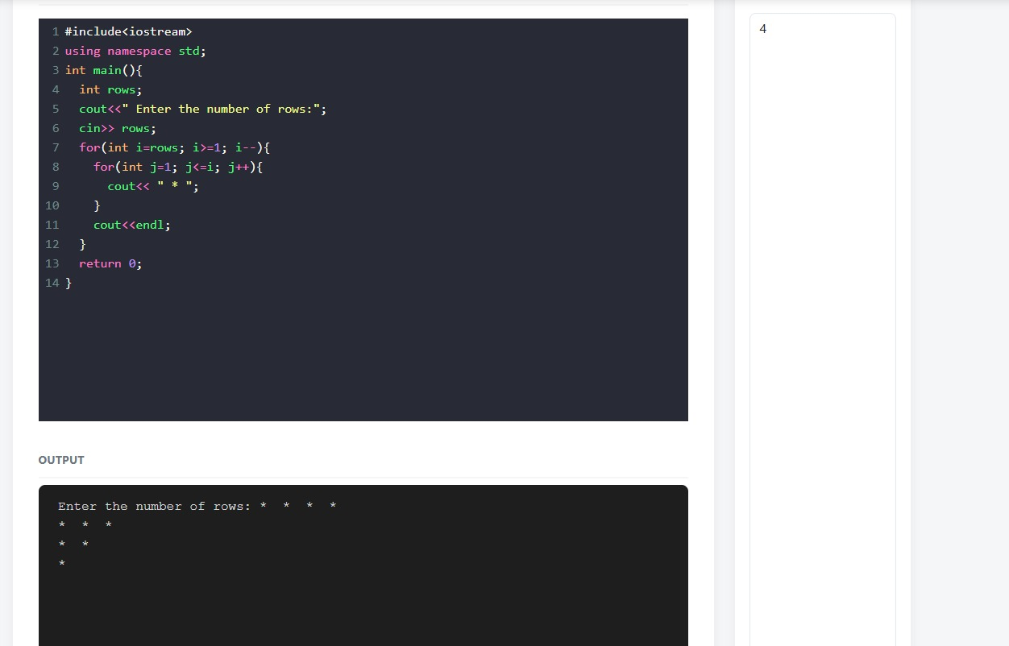

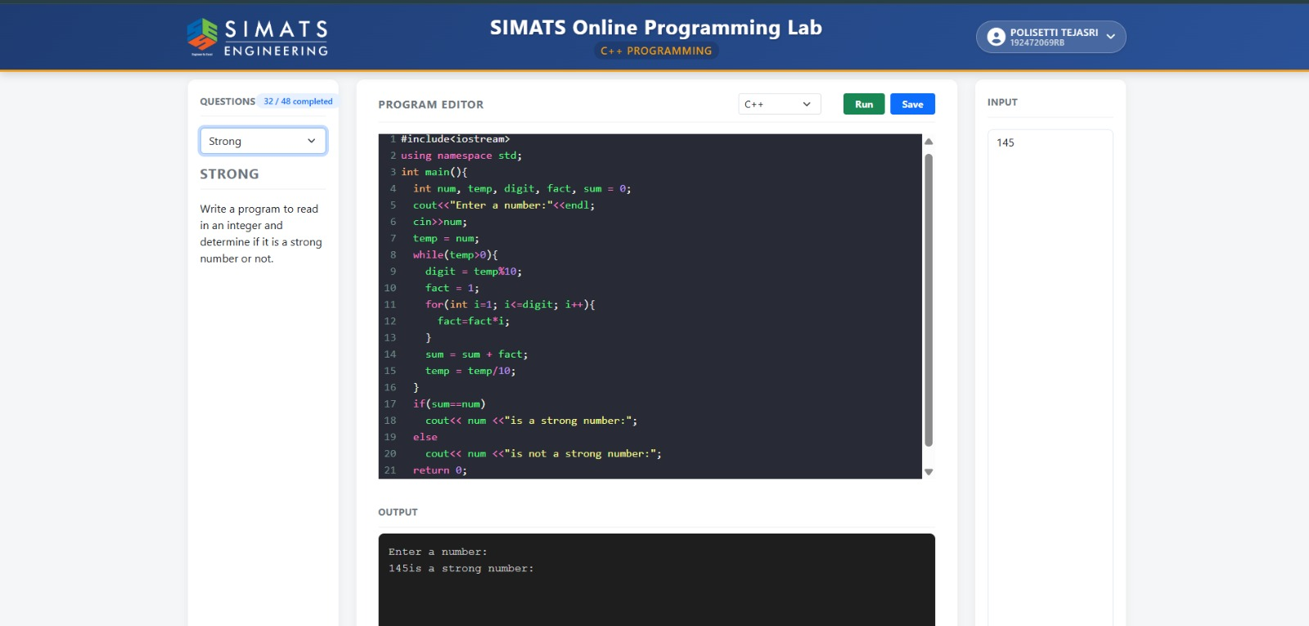
2.Check whether a number is a Strong number.
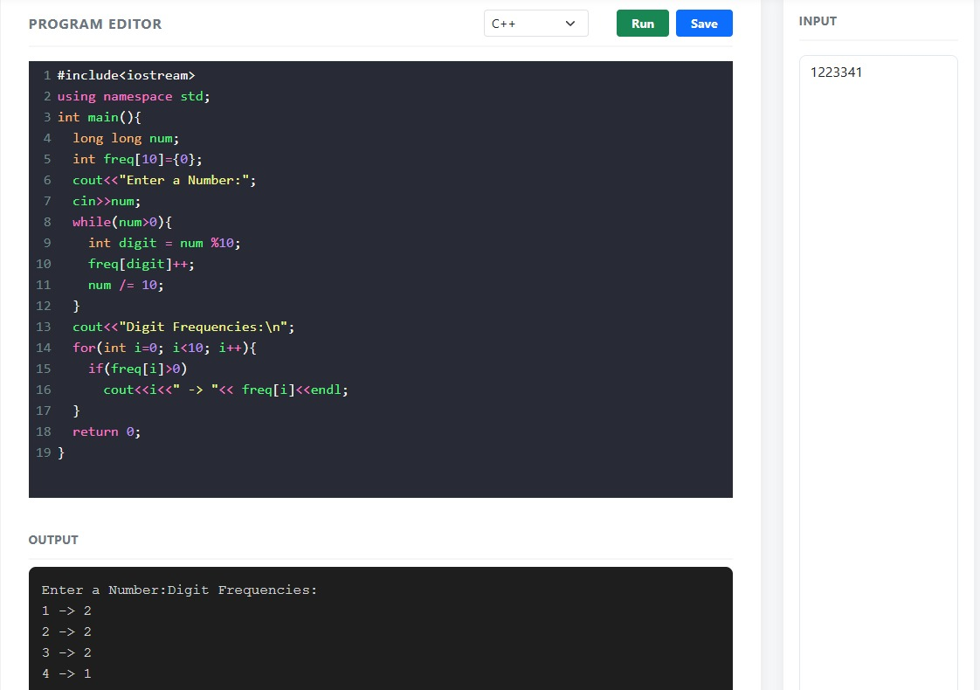
3.Count the frequency of each digit in a number.

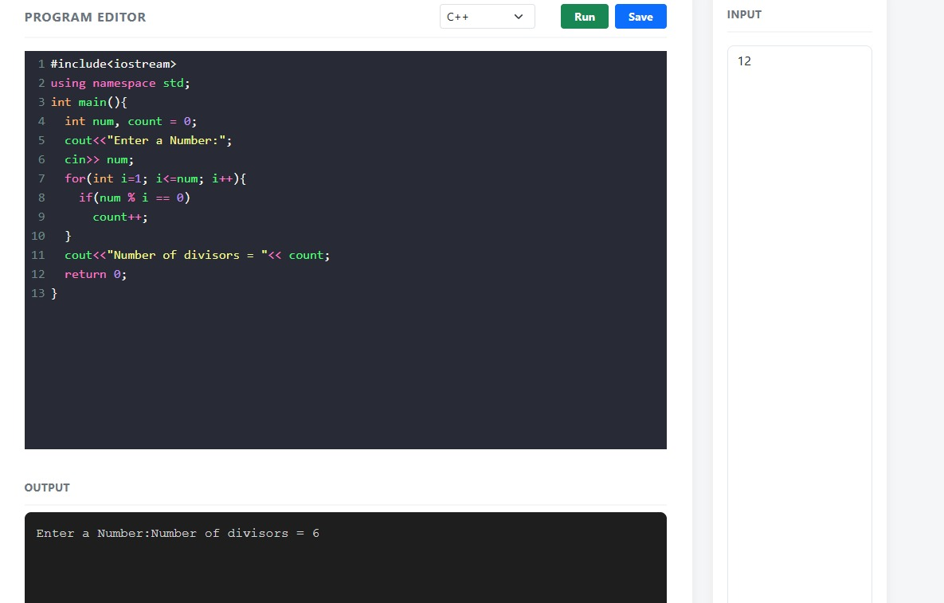
4.Count the number of divisors of a number.

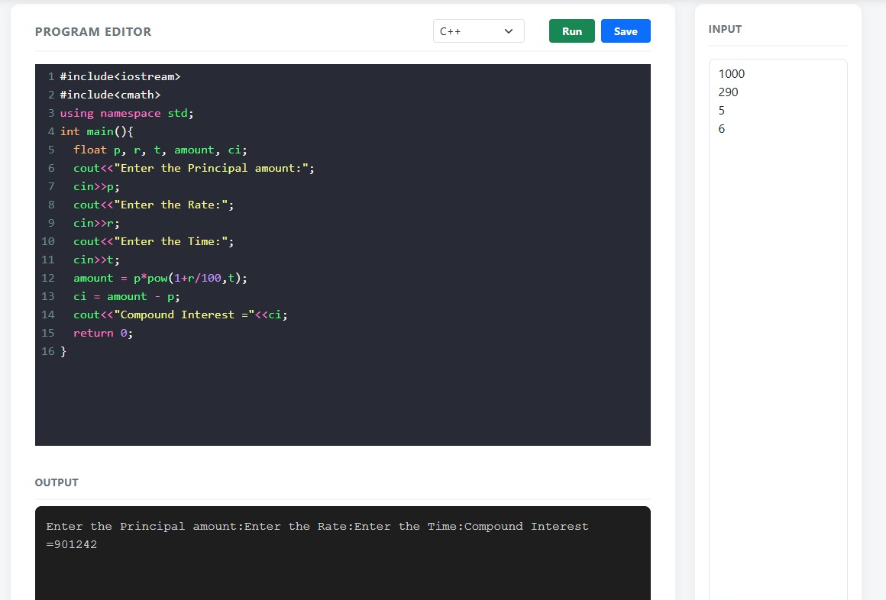
5.Calculate compound interest.

